**PYTHON FOR DATA TRANSFER USING JSON**

JSON stands for JavaScript Object Notation and is a lightweight format for storing and transporting data and it is often used for sending data from web service.

How JSON would be used to transfer images between mobile to server

From mobile to server

Steps:

1. Convert the image into a Base64 string.

Steps: Open an image file.

Read the image data.

Encode it in base64 using base64 modules in python.

Print the string.

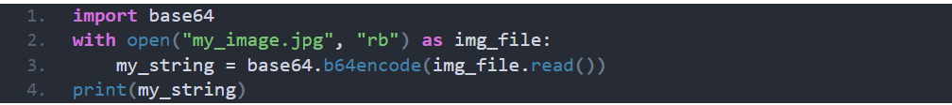

*Figure1: example code for converting an image into base63 string.*

1. Use Python Requests library.

The library is used for sending HTTP request in python and it supports SSL connections, international domain names. It automatically encodes POST data, formats JSON, decompresses server responses and has built-in proxy support.

Steps: Install python request library.

Use python request POST method.

*Figure1: example code for sending JSON data using Request library.*

From server to mobile

Steps:

1. Use python request library, call the request.get()

References

1. <https://reqbin.com/code/python/m2g4va4a/python-requests-post-json-example>
2. <https://realpython.com/python-json/>
3. <https://www.quora.com/How-do-I-send-a-person-details-and-several-images-via-JSON-in-Android>
4. <https://www.codespeedy.com/convert-image-to-base64-string-in-python/>